**PSG College of Technology**

**Department of Computer Applications**

**MCA**

**Bridge Course - Python Programming**

1. Write a program to compute the area of a square or area of a circle after prompting the user to type the first character of the name (‘S’ for square or ‘C’ for circle).
2. Write a program to implement the flowchart.

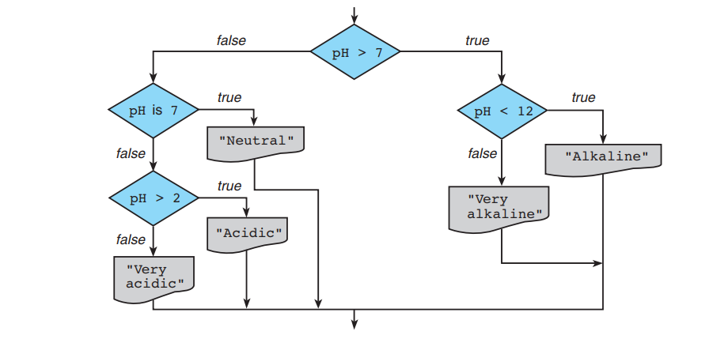

1. Write a program that reads a ship’s serial code and displays the class of the ship. Each ship serial code begins with a letter indicating the class of the ship.

|  |  |
| --- | --- |
| B or b | Battleship |
| C or c | Cruiser |
| D or d | Destroyer |
| F or f | Frigate |

1. Write a program to calculate the square of those numbers only whose least significant digit is 5.
2. Write a program that calculates the body mass index (BMI) and categorizes it as underweight, normal, overweight, or obese, based on the following table

|  |  |
| --- | --- |
| **BMI** | **Weight status** |
| Below 18.5 | Underweight |
| 18.5–24.9 | Healthy |
| 25.0–29.9 | Overweight |
| 30.0 and above | Obese |

To calculate BMI = weight in Kg / (height in meters)2

1. A company has the following discount policy. If the purchase is for under Rs.2000, no discount is given. On purchases for Rs. 2000 and above but less than Rs.5000 a discount of 5% is given. On purchase of goods for Rs. 5000 and above a discount of 8% is given. Write a program to accept the purchase amount and print the final bill amount.
2. Write a program to calculate the Electricity bill. Read the previous and current meter reading. The charges are as follows.

|  |  |  |  |  |
| --- | --- | --- | --- | --- |
| No of units | Fixed Charge | From | To | Cost per unit |
| <=100 | Rs.0 | 1 | 100 | Nil |
| <=200 | Rs.20 | 101 | 200 | Rs.2 |
| <=500 | Rs.30 | 101 | 200 | Rs.2 |
| 201 | 500 | Rs.3 |
| >500 | Rs.50 | 101 | 200 | Rs.3.50 |
| 201 | 500 | Rs.4.60 |
| >500 | | Rs 6.60 |

1. Admission to a professional courses is subject to the following conditions:
   1. Marks in Mathematics >=60
   2. Marks in Physics >=50
   3. Marks in Chemistry >=40
   4. Total in all three subjects >=200 (or) Total in Mathematics and Physics >=150

Write a program to check whether a particular student’s mark is eligible for admission or

not.

1. The basic eligibility criteria required to apply for any SBI Credit Cards are as follows,

* Age of the primary applicant must be between 21 years to 60 years.
* Age of the add-on card applicant must be above 18 years.
* Must be either salaried, self-employed, student, or retired pensioner.
* Primary applicant should have a stable income (gross) of upto Rs.3 lakh per year.

Accept required inputs from the user, Write a program to check if the person meets

the bank’s eligibility criteria.

1. Write a python program to print all numbers in a range 700 to 900 (inclusive)

divisible by a given number from user.

1. Write a Python program to check whether a specified value is contained in a group of

values.

1. Write a python program to read three numbers (a,b,c) and check how many numbers

between ‘a’ and ‘b’ are divisible by ‘c’.

1. Write a program to get 4 digit pin number from the user. If the user enters 7878,

display a message “Welcome to SBI Banking” else if the user enters any other

number display a message “Enter a valid pin number”.

Expected Output:

Enter the PIN: 7878

Welcome to SBI Banking

Enter number2: 1024

Please enter a valid pin number

1. Write a Python program to create a histogram from a given list of integers.

Input: Character to pint: $

Format to print: 4162

Output:

$$$$

$

$$$$$$

$$

1. A hotel has a pricing policy as follows:

a. 2 people: Rs.5000  
 b. 3 people: Rs.6000  
 c. 4 people: Rs.7000  
Additional people (max 2 are allowed): Rs.500 per person  
If the customer is staying on company business, there is a 20% discount. If the customer is over 60 years of age, there is a 15% discount. A customer does not receive both discounts. Write a program to print the cost of the room for the given input.

***************